

**UNIFIED MENTOR PRIVATE LIMITED**

**Intern name: Kumari Shruti Jha**

**Role: Data Analyst Intern**

**Internship Id: UMIP8809**

**Date of Submission: 15-07-2024**

**Contact Info: Email:**[**Shrunov17@gmail.com**](mailto:Shrunov17@gmail.com)

**Mobile no.: 8789819002**

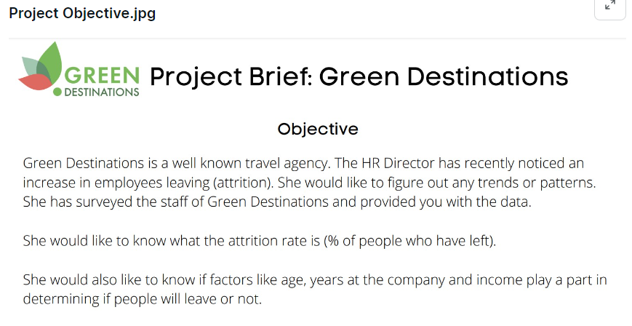

For this project, I have primarily used python for data analysis as I want to hone my skills in python. The approach that I have followed is:

1. Use the dataset to evaluate the correlation matrix between attrition and all of the other parameters and visualize this as a heatmap. Then I am using the correlation values to evaluate the top parameters which are closely related to the attrition rate, while ensuring that parameters such as Age', 'YearsAtCompany', and 'MonthlyIncome' are always included in my analysis.
2. After the identification of top parameters, I used statistical properties like visualizing the probability distribution, the mean and standard deviation to understand which parameters are most significant in deciding the attrition rate.
3. The plots for all of these parameters have been included.
4. Attrition Rate:

The approach used to calculate the attrition rate was to evaluate the no of Yes’s in the” Attrition” column in the dataset and divide it by the total number of entries, which came out to be **16.12 %**

1. Monthly Income Parameter

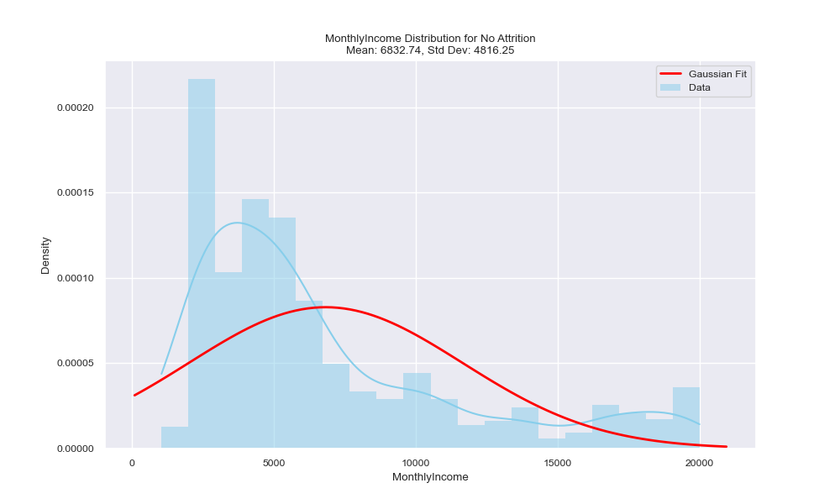

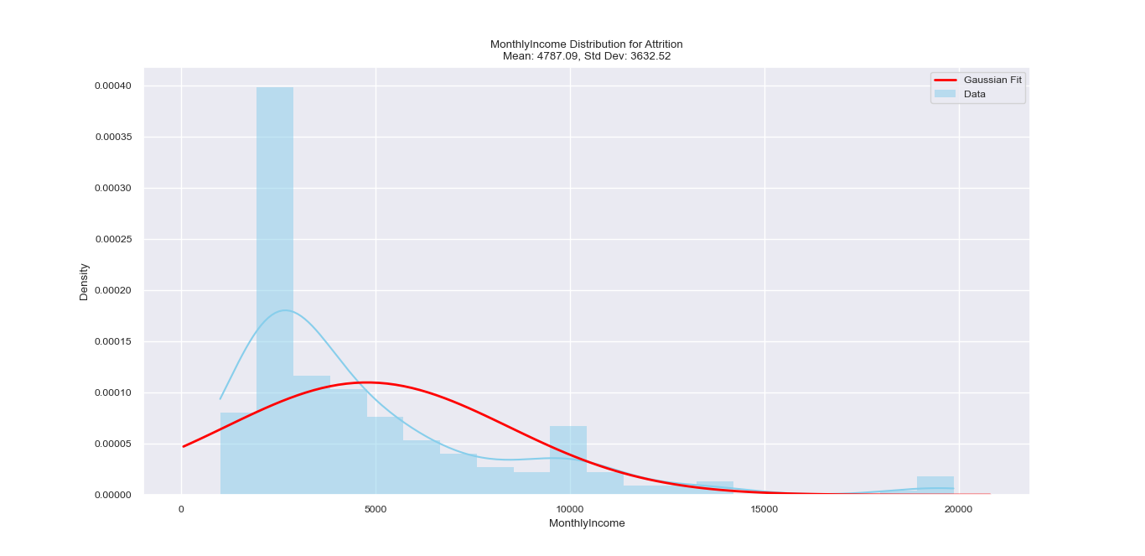

It can be seen that the avg monthly income is just 4787 for those who leave the company, which is considerably lesser than the avg income of those who stay.

1. Age of Employees:

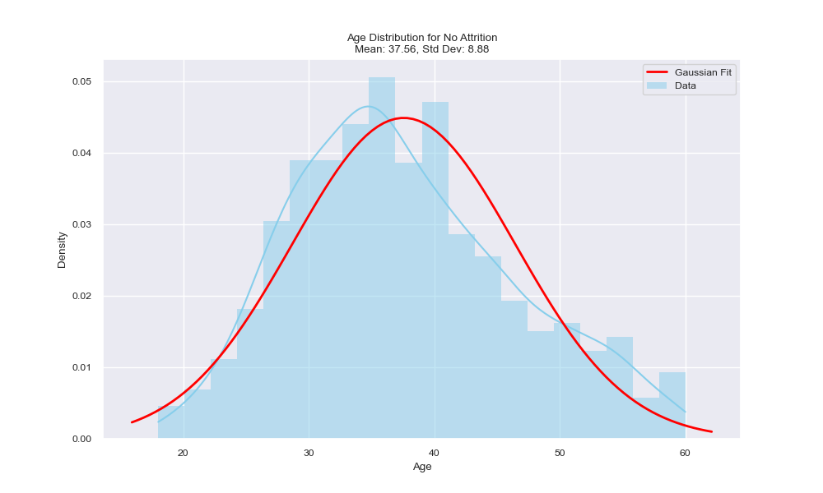

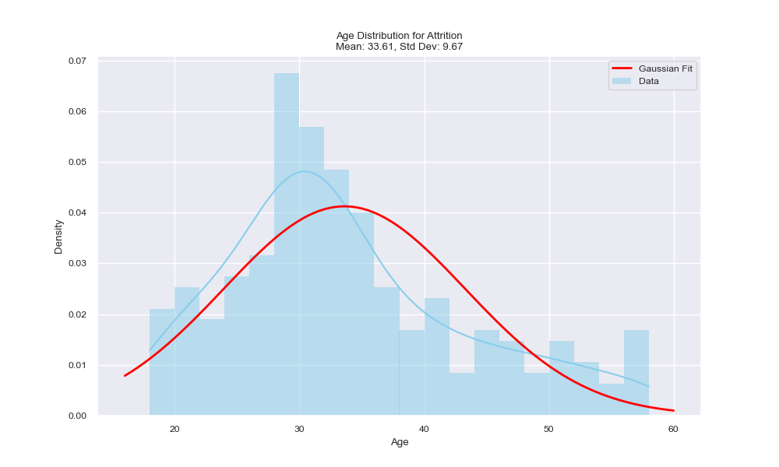

The average age when people leave the company is much less, that means that young people leave the company more to venture out for more opportunities.

1. Job Level

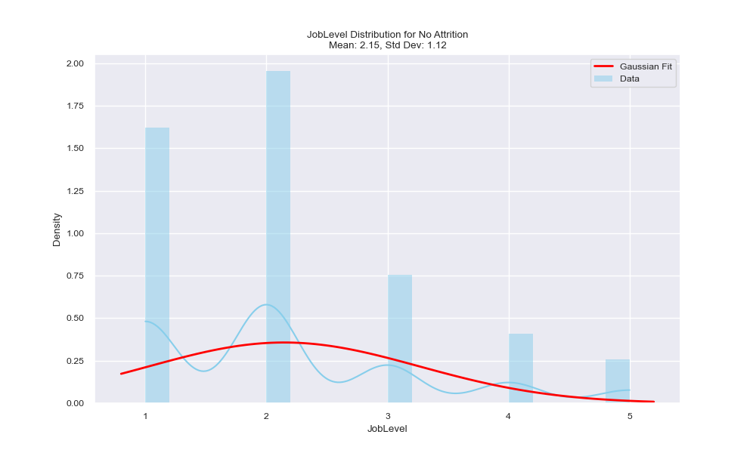

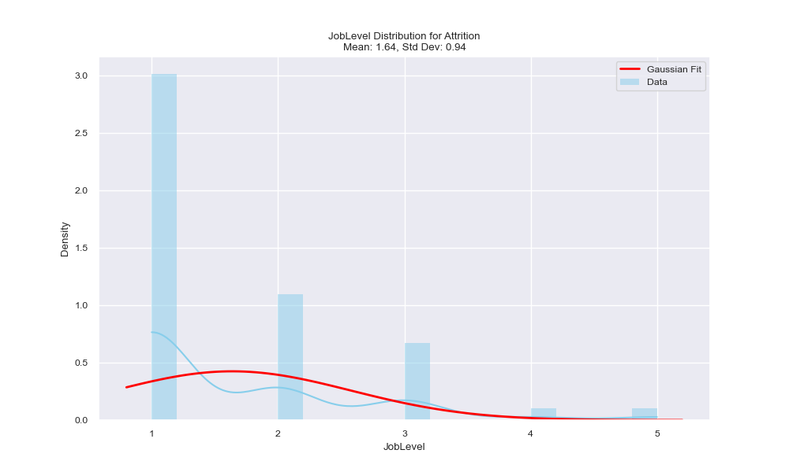

For those who leave the job level is again much lower, it is only 1.64 as compared to the mean value of 2.15 of those who stay.

1. Working years Parameter

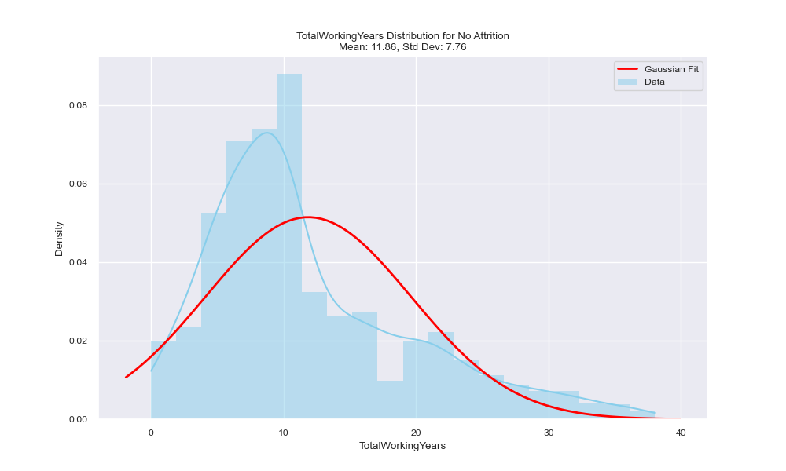

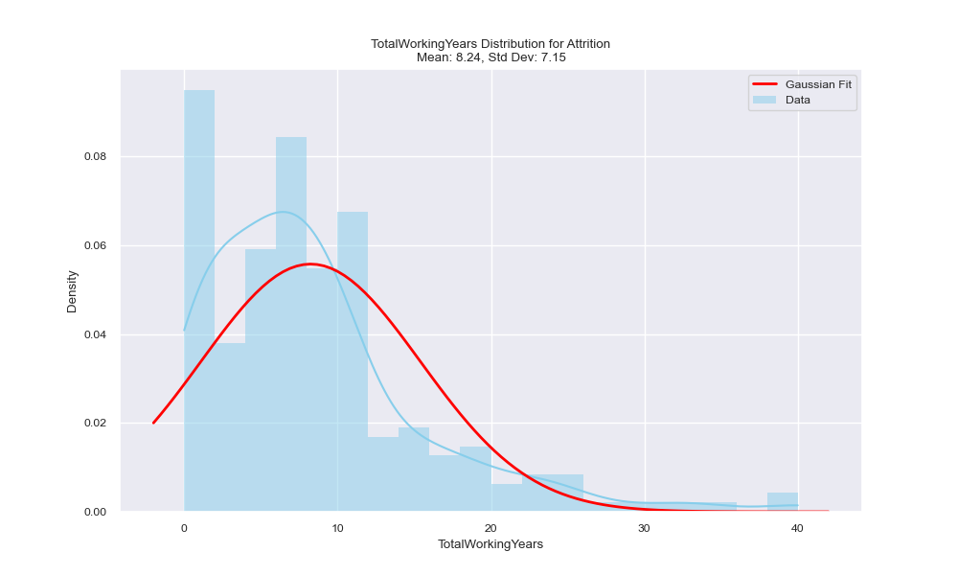

The same pattern can be seen in the working years parameter too, wherein the people leaving the company have less mean value of working years.

1. Years at company:

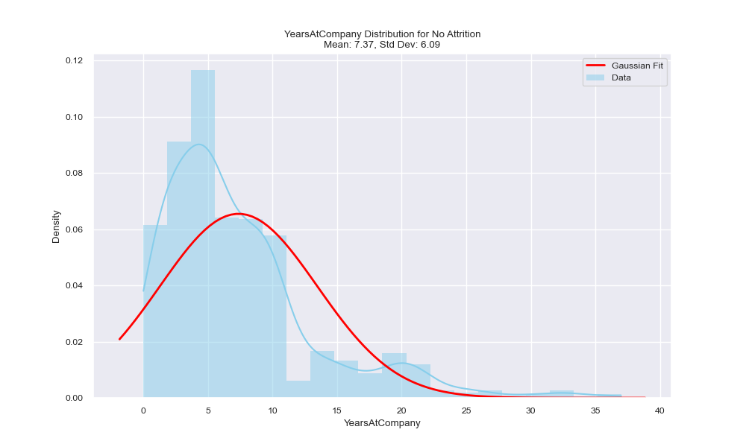

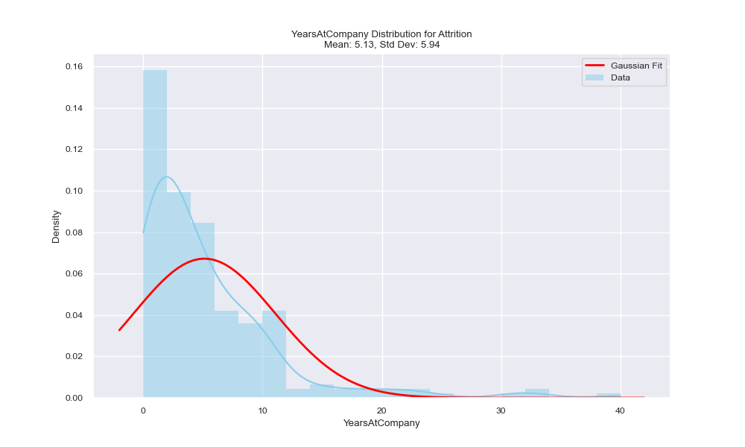

Again, the same pattern can be seen here too. Therefore, to conclude, the selected relevant parameters indicate that young people with less monthly income and lesser designation at their jobs are more likely to leave the company, the HR can work with these insights.

1. Correlation Matrix:

As discussed earlier, the correlation matrix has been used to decide the top parameters. The following figure will show the correlation heatmap. Using the parameters in this correlation matrix the relevant parameters have been identified as follows: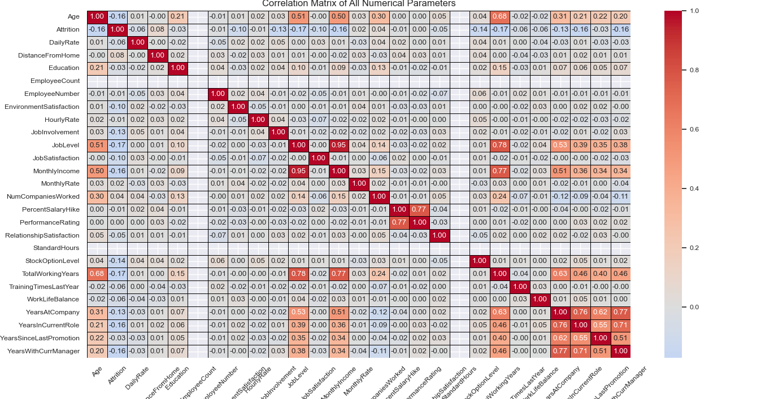

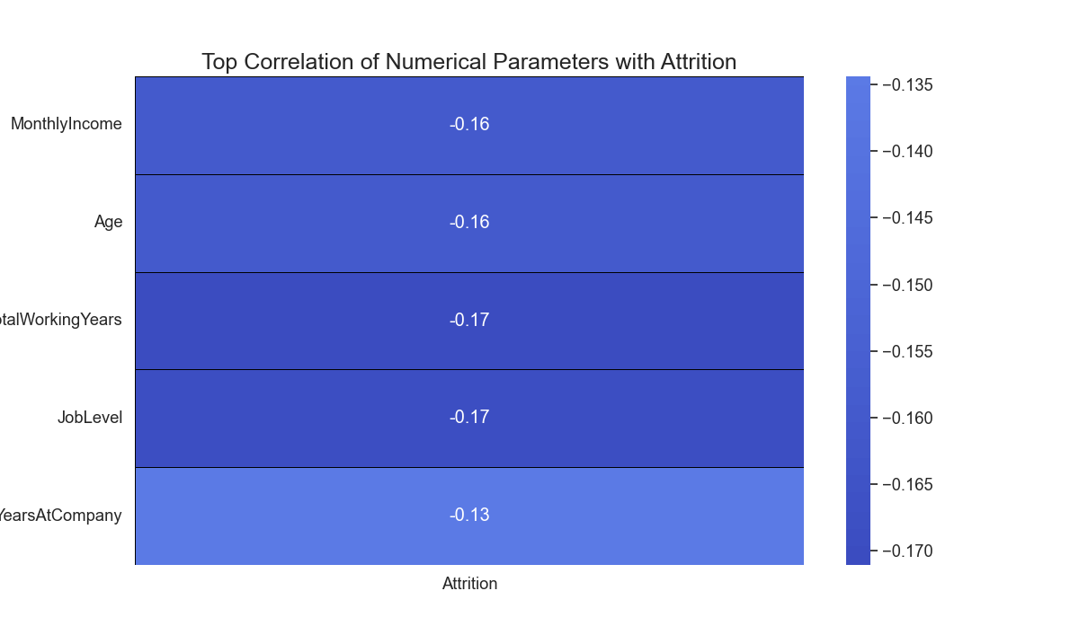

The relevant parameters as identified by correlation.